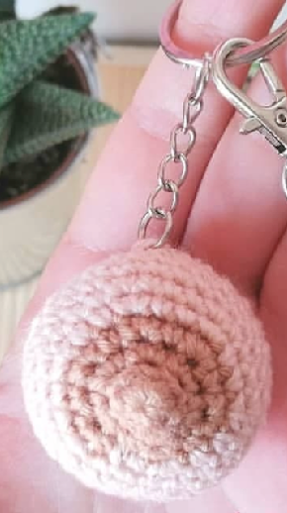**Boob Crochet Pattern**

***\*2.5mm Hook\****

*Nipple Colour*  
R1: SC6 in MR [6]

R2: SC6 [6]

R3: Inc x6 [12]

R4: (SC, Inc) x6 [18]

*Skin Colour*

R5: SC, Inc, (SC2, Inc) x5, SC [24]

R6: (SC3, Inc) x6 [30]

R7-11: SC around [30]

R12: (SC3, Dec) x6 [24]

R13: (SC2, Dec) x6 [18] *Stuff*

R14: (SC, Dec) x6 [12]

R15: Dec x6 [6]

Fasten off and close hole.

**Ribbon;**

Ch20, HDC back until the end.